Name__________________________________________________ Notes – Crime Scene
The Crime Scene
“Wherever he steps, whatever he touches, whatever he leaves, even unconsciously, will serve as a silent witness against him. Not only his fingerprints or his footprints, but his hair, the fibers from his clothes, the glass he breaks, the tool mark he leaves, the paint he scratches, the blood or semen he deposits or collects. All of these and more, bear mute witness against him. This is evidence that does not forget. It is not confused by the excitement of the moment. It is not absent because human witnesses are. It is factual evidence. Physical evidence cannot be wrong, it cannot perjure itself, it cannot be wholly absent. Only human failure to find it, study and understand it, can diminish its value.”
—Professor Edmond Locard

Lesson 1 – Forensic Science Introduction
Sir_____________________________________
- 19th century (1800’s)
- Author of ___________________________________________
- First to apply ___________________________________________
__________________________________to investigations
Alphonse Bertillon (1853-1914)
- 1st scientific system of________________________________
- __________________________________(body measurements)
- “Father of criminal identification”
Edmond Locard (1877-1966) - Set up _____________________in France

Locard’s Principle - “Every contact leaves a trace”
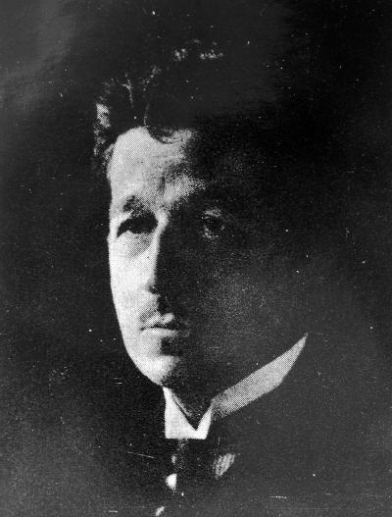 When a criminal _____________________________
_________________________________________________________
J. Edgar Hoover (1895-1972)
- Was head of the __________________
- 1932- organized a national _________________________________
- Set up ____________________ services to all parts of United States
“Forensic Science” 
Let’s break down the 2 words
Science – ______________________________________________________
Forensics - ____________________________________________________
What is forensic science?
______________________________________________________________
______________________________________________________________
Legal system includes: ______________ courts & _______________ courts

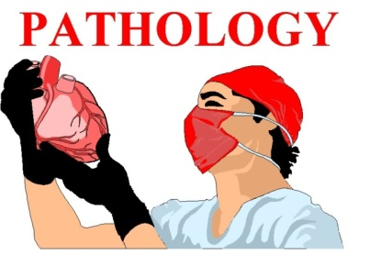
Pathology
- The medical specialty that deals with _____________________________
_________________________________________________________
Medical Examiner
- Is a licensed __________________________________
  - Graduation from ___________________ school
  - Completion of residency in __________________________
  - Fellowship in forensic __________________________
Functions of the M.E. – Determines:
- 1) _______________________________________
- (Body temperature, stomach contents, insects)
- 2) _________________________________________
- (gunshot, broken neck, poisoning, disease, etc.)
- 3) _______________________________________
- (Homicide, suicide, accidental, natural)
Reportable Cases -______________________________________
“By law, the Medical Examiner must be notified of any death which occurs suddenly and unexpectedly while the victim is in apparent good health, or whenever there is a suspicion that the death may be unnatural. Also reportable are deaths which occur in the workplace, and cases of public health interest (e.g. suspected but undiagnosed possible tuberculosis, meningococcemia, anthrax, tuleremia, etc.).” SCME
Autopsy
- Dead body is now _____________________________________
- M.E. examines the body ______________________ (usually 1 to 1.5 hours)
Coroner vs. Medical Examiner
- Coroner -
- ______________________________official
- May not have ______________________ background
- Can call on a specialist
- Medical Examiner-
- Specialist (Licensed ___________________)
- Appointed
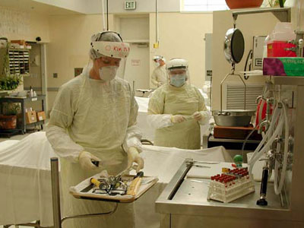

Lesson 2 – Forensic Entomology
What is forensic entomology?
- Forensic Entomology is the use of __________________________
_________________________________________
Most Important Environmental Factors in Corpse Decay
- _____________________________
- Access by _________________________
- Depth of _____________________________________
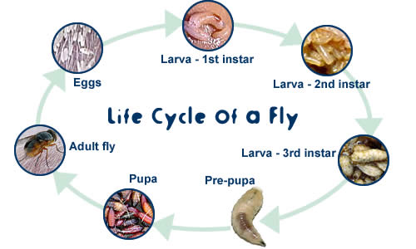

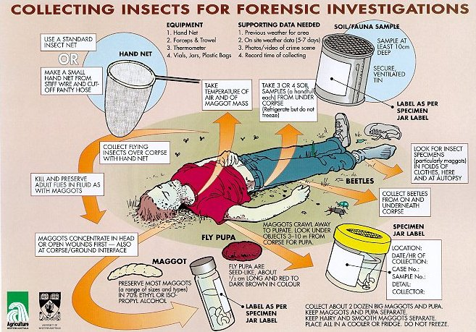

Lesson 3 - CRIME SCENE INTRO
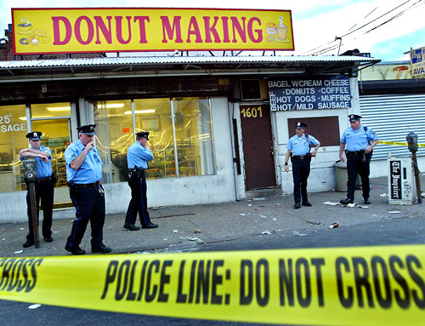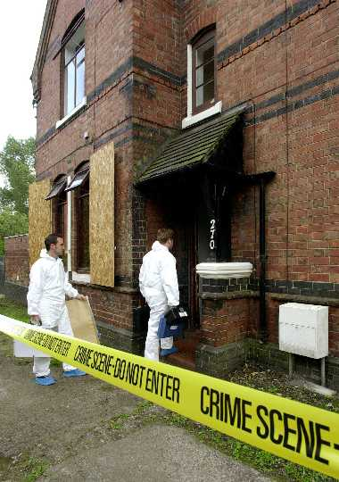
Felony - Punishable by _____________________________________________ ________________________________________________________in a state prison.
Misdemeanor - Punishable by ________________________________________ _________________________________________________in a local or county jail.
Infraction or Violation - Minor offenses punishable by a fine only.
Corpus delicti - “Body (essential elements) of the Crime
  - You must prove :
  - that a _____________________________________________
  - that the person charged with the crime ___________
_________________________________________________________
Source of Evidence

CRIME SCENE TEAM
- Team Members
  - ____________________________________on the scene
  - ________________________________ (if necessary)
  - _________________________________
  - __________________________________ (if necessary)
  - _____________________________________
  - _________________________________

CRIME SCENE INVESTIGATION
- Involves:
  - ___________________—scene survey, documentation, collection
  - _____________________________________—comparison testing
  - ____________________________—evaluation and interpretation
  - __________________________________—reporting and presenting
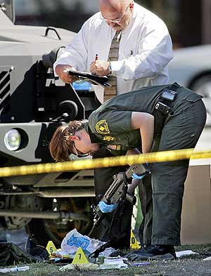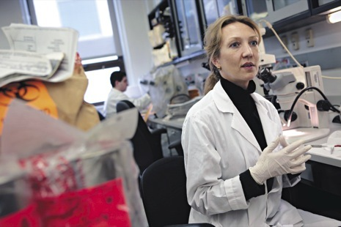

Walk-through—performed by the crime scene investigator, the first officer and sometimes the lead detective
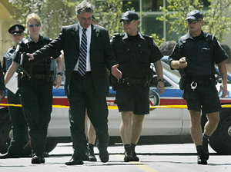
Purpose:
  - Mentally prepare a __________________________________theory
  - Note any transient or conditional ______________________ that could change over time
  - Note ________________________________ conditions
  - Note points of ______________________________________, as well as paths of travel within the crime scene
  - Record initial observations of _________________________________________________________________
  - Identify _____________________________________ within the crime scene for personnel, precautions or equipment and notify superior officers or other agencies
COLLECTING AND PACKAGING EVIDENCE
- _____________________________should be designated as the evidence collector to ensure that the evidence is collected, packaged, marked, sealed, and preserved in a _______________________________
- Most items should be packaged in a _____________________________ and then placed inside a ___________________________________. These are then placed inside other containers such as paper bags, plastic bags, canisters, packets and envelopes depending on the type and size of the evidence.
CHAIN OF CUSTODY
There must be a ____________________________________________ of all people who had ______________________________of an item of evidence.
What will happen if the chain of custody is broken?
____________________________________________________________________________
Crime Scene Reconstruction
Initial _____________________________________leads to the formation of ______________________________________ (guesses as to what happened)
Hypotheses are tested by additional _______________________________
Disproved ___________________________________________ are thrown out, leaving a ___________________________________________________________
Stages
  - ____________________________collection
  - __________________________________ formation
  - ____________________________________________ and analysis
  - Determination of the significance __________________________
  - _________________________________________________ formulation
  - (Scientific Method!)
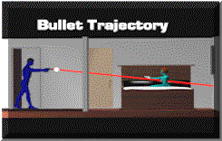
Lesson 4 - Processing the crime scene
- ___________________________________________________________
- Mnemonic device to remember steps
1st “P” -_________________________________________________________________
The number one priority is _____________________________________________ at the scene; even if that means disturbance of possible evidence.
2nd“P” - _____________________________________________________________________
-_________________________________________
-________________________________________
-limit and document ____________________________________________________
3rd “P” - ___________________________________________________________________
- ___________________condition! – before anything touched or removed
- If evidence moved or removed, it must be ____________________________
- Comprehensive – every possible _____________________, ____________________ of anything that may aid in solving the crime
- Overlapping segments in one direction
- After removal of the body, _______________________________________________
- _______________________________________________________
“S” - ____________________________________________________________
“C” - ____________________________________________________________
_____________________________________________________________
- Most fragile is ____________________________________________________
- Different types of evidence require specific or special collection and packaging techniques
- The body is the property of the__________________________________. The collection of evidence on the __________________ is done by that department
Collect enough of each piece of evidence for:
- 1) ______________________________________________________________
- 2) ______________________________________________________________
- 3) ______________________________________________________________
- Collect ________________________________________samples – substances that may have been a contaminant
Ie- ________________________________________________ area nearby
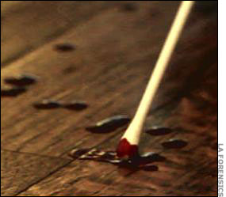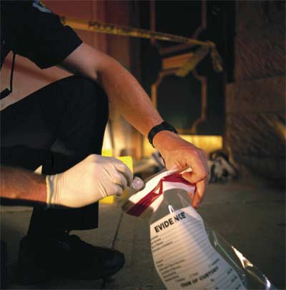
“R” - ________________________________________________________________________
- Date - the date the evidence was collected.
- Case # - the case number to which the evidence applies. This number is assigned by the lead investigator and should be unique for each incident investigated.
- Consent Required - whether the investigation required the consent of the owner to search.
- Signature of consenting person - if the consent was required, the signature of the owner.
- Tag # - the unique number within the case number assigned to the evidence. These numbers are sequential for each piece of evidence in the case.
- Description of item - a description of the evidence and any other pertinent notes.
- Person receiving evidence - the name of the person collecting the evidence.
- Signature - the signature of the person receiving the evidence.
- “The note taker has to keep in mind that this written record may be the only source of information for refreshing one’s memory months, perhaps years, after a crime has been processed. The notes must be sufficiently detailed to anticipate this need” – Saferstein
“I” - ______________________________________________________________________
-through __________________________________________________________
-experienced investigators – ______________________________________________
at crime scene

“P” - ______________________________________________________________________
- _________________________________________ separately
-Why would we _____________________________________ items separately?
do not want ________________________________________________
Protect by __________________________________________
Investigators name/initials and date should be ___________________________

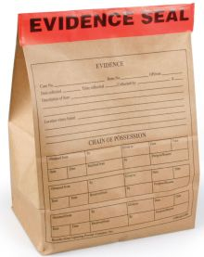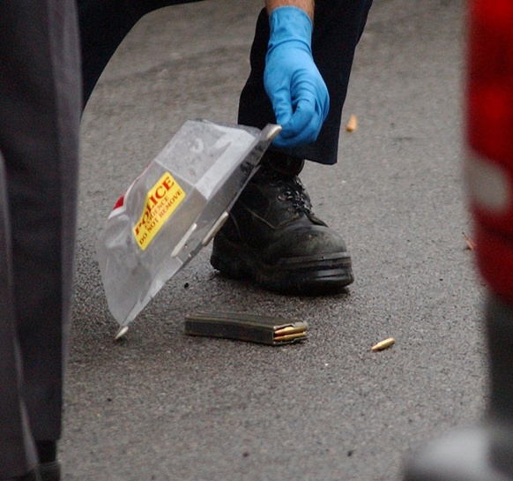

“T” - ________________________________________________________________________
______________________________________ with care
ie- __________________________ on CS van, ________________________________

Lesson 5 – Crime Scene Searches
- __________________________________________________ search
- Do not dismiss anything until its ___________________________________________ can be determined
- If a crime scene investigator __________________________________ on the ground at various angles, even when there's plenty of lighting, he'll create new shadows that could reveal _______________________________.
Under the __________________ Amendment, to conduct a search, police need...
- ___________________or a reason to suspect, that a person has committed a crime,
- ______________________________ or permission, from the person or property owner,
- or a _____________________________________________
What Happens When The Law Isn’t Followed?
- ___________________________________________________________________
- ___________________________________________________________________
- ___________________________________________________________________
In some situations investigators do not need a ___________________ to conduct a search.
- ______________________________________________ - If an individual voluntarily consents (agrees to) a search, no warrant is needed.
- _____________________________________________- A police officer that spots something in _______________________________does not need a search warrant to seize the object. In order for a plain view search to be legal, the officer must be in a place he has the right to be in and the object he seizes must be plainly visible in this location.
- If a suspect has been legally____________________________, the police may search the defendant and the area within the defendant's immediate control. In a search incident to arrest no warrant is necessary as long as a spatial relationship exists between the defendant and the object.
- Following an arrest, the police may make a ___________________________ if they reasonably believe that a dangerous accomplice may be hiding in an area near where the defendant was arrested. To do so, police are allowed to walk through a residence and complete a "cursory visual inspection" without a warrant. If evidence of or related to a criminal activity is in plain view during the search, the evidence may be legally seized.
- If the police stop a car based on_____________________________, they can search for objects related to the reason for the stop without obtaining a warrant. During a car search, the police are also allowed to frisk the subject for weapons, even without a warrant if they have reasonable suspicion that the suspects may be involved in illegal activities
Which should be searched first: outdoor or indoor sites? Why?
__________________________________________________________________________________
The_______________________________________________________: The CSI starts at the perimeter of the scene and works toward the center. Spiral patterns are a good method to use when there is only one CSI at the scene.
Draw an inward spiral search:

The outward spiral search: The CSI starts at the center of scene (or at the body) and works outward.
Draw an outward spiral search:

The ________________________________________________________: All of the members of the CSI team form a line. They walk in a straight line, at the same speed, from one end of crime scene to the other
Draw a parallel search:

The __________________ search: A grid search is simply two parallel searches, offset by 90 degrees, performed one after the other
Draw a grid search:

In a ______________________ search, the CSI in charge divides the crime scene into sectors, and each team member takes one sector. Team members may then switch sectors and search again to ensure complete coverage.
Draw a zone search:

